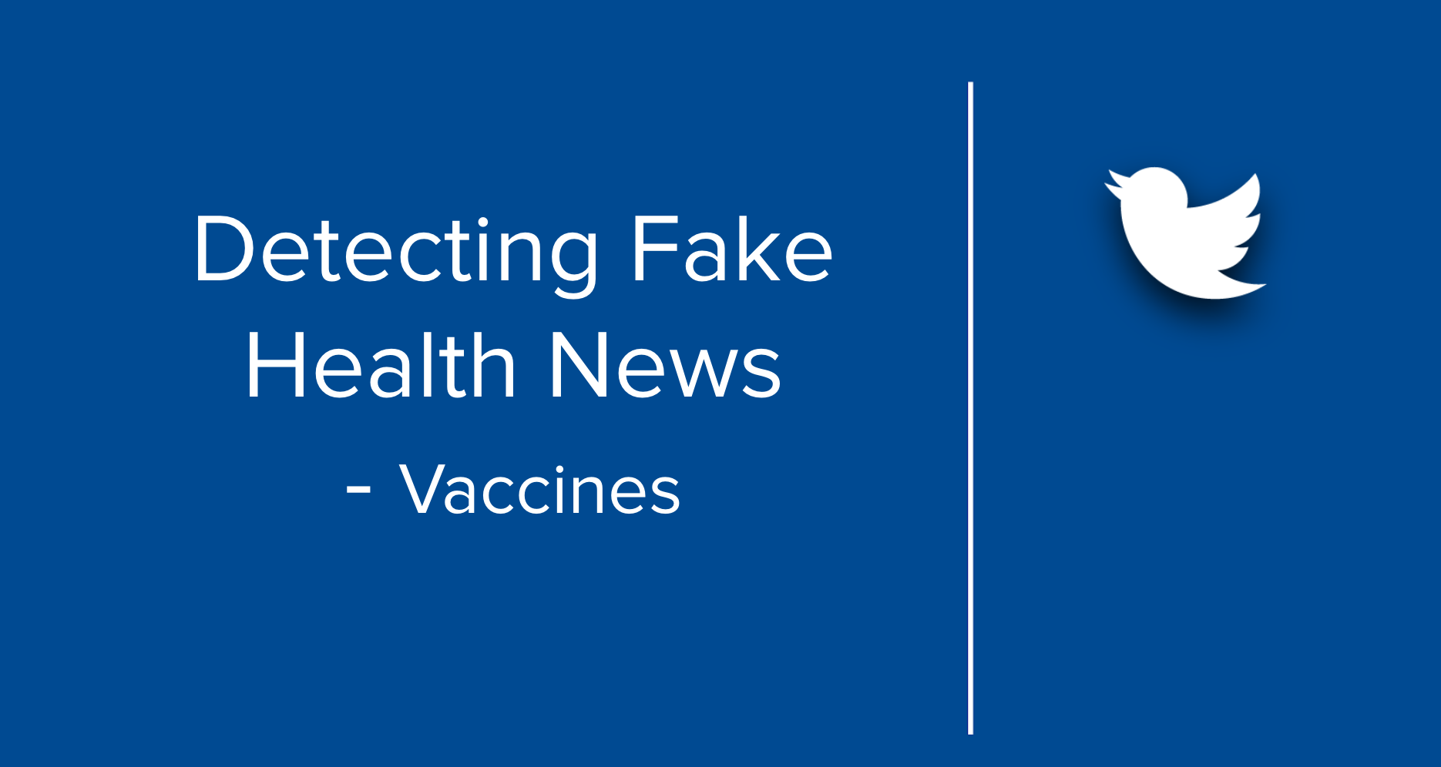

Mohammed Rehan

Phil Greene

Sheethal Sridhar

Shubham Puri

# Contents

Problem Statement 2

Objective 2

Process 2

Tools Used 2

Data Collection 3

Data Description 3

Fact Repository 4

Classification 6

Analysis 7

Appendix 11

### 

### **Problem Statement**

False news spread faster than the truth. There is worldwide concern over false news and the possibility that it can influence political, economic, and social well-being. Motivations of its creators vary, but fake medical news can earn clicks and “likes,” which can translate to add revenue, or further become an agenda for large-scale investments. The degree of novelty and the emotional reactions of recipients may be responsible for the differences observed. False information can also drive the sale of expensive, unproven treatments. Unproven remedies may be harmful, waste money and sometimes, using these remedies keeps people from getting the medical treatment they need.

### **Objective**

* Our primary goal was to be able to detect fake tweets about ‘vaccines’ using Machine Learning models.
* Furthermore, to analyze the fake tweet characteristics and user characteristics.

### **Process**

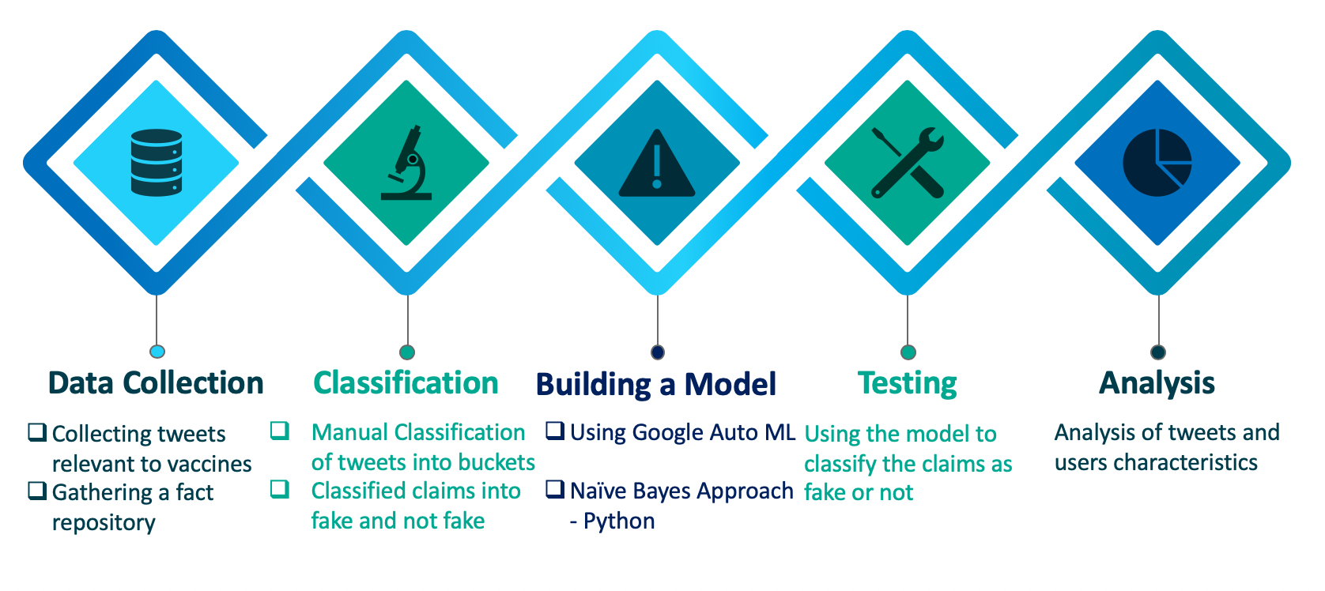

### **Tools Used**

**R -** tweet scraping and visualizations

**Python -** claims classification

**Google’s AutoML -** buckets classification

**Tableau -** Visualization

### **Data Collection**

Used the Twitter API to collect tweets in R. In a period of 4 weeks, collected a total of 20,000 tweets. Tweets were collected using the words ‘vaccines’ and ‘#vaccines.

Keywords used: *"vaccines", "#vaccines"," Vaccines", "#Vaccines")*

After removing the duplicates, 18,209 tweets were left.

### **Data Description**

Below is the table of metadata for the dataset. Highlighted are the column we created for our analysis

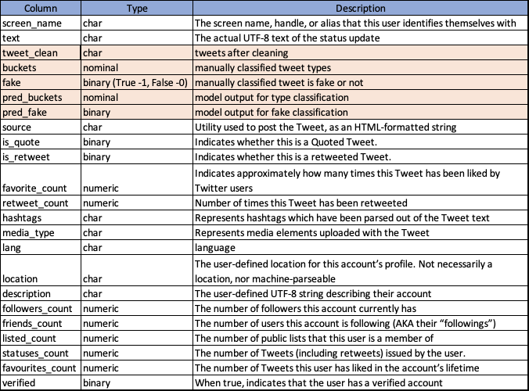

### **Fact Repository**

Analyzed multiple sources to gather a fact repository of vaccines. There were 16 most prominent myths prevalent among all the sources related to vaccines. Our primary sources for facts were from:

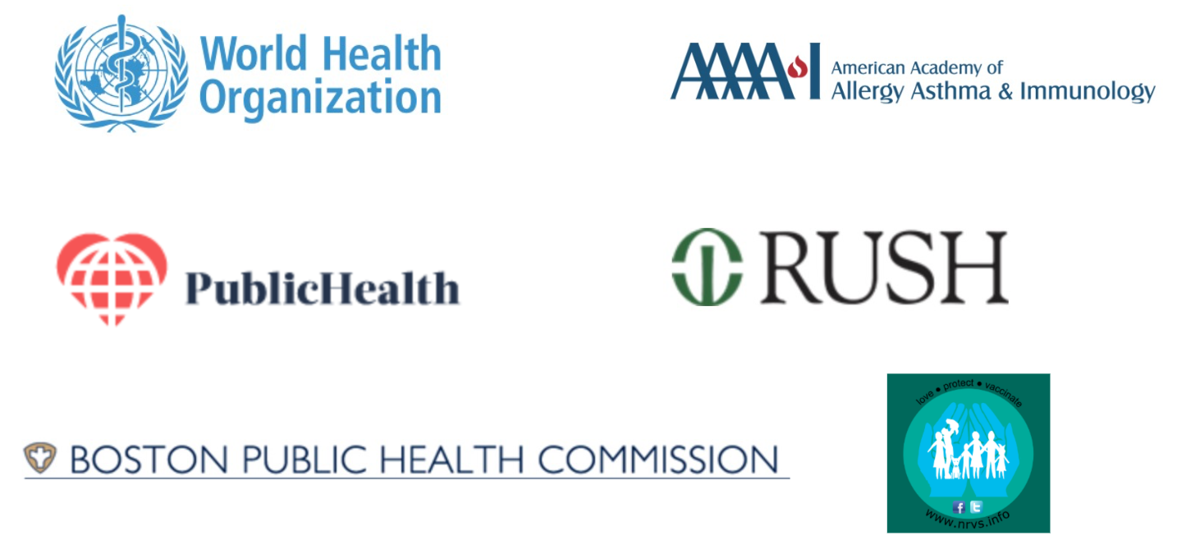

**Fact Repository Table**

|  |  |  |  |
| --- | --- | --- | --- |
| **Id** | **Myth** | **Fact** | **Resource** |
| 1 | Vaccines cause autism | Symptoms of autism in children develop well before they receive the MMR vaccine | https://www.publichealth.org/public-awareness/understanding-vaccines/vaccine-myths-debunked/ |
| 2 | Infant immune systems can’t handle so many vaccines | A baby would theoretically have the ability to respond to around 10,000 vaccines at one time | https://www.publichealth.org/public-awareness/understanding-vaccines/vaccine-myths-debunked/ |
| 3 | Natural immunity is better than vaccine-acquired immunity | Vaccine acquired immunity is more efficient than natural immunity | https://www.publichealth.org/public-awareness/understanding-vaccines/vaccine-myths-debunked/ |
| 4 | Vaccines contain unsafe toxins | Trace amounts of these chemicals are used in FDA approved vaccines hence safe | https://www.publichealth.org/public-awareness/understanding-vaccines/vaccine-myths-debunked/ |
|  |  |  |  |
| 5 | Better hygiene and sanitation are actually responsible for decreased infections, not vaccines | The effect of vaccines on curing diseases outweighs sanitation and hygiene | https://www.publichealth.org/public-awareness/understanding-vaccines/vaccine-myths-debunked/ |
| 6 | Vaccines aren’t worth the risk. | The overall incidence rate of severe allergic reaction to vaccines is usually placed around one case for every one or two million injections. | https://www.publichealth.org/public-awareness/understanding-vaccines/vaccine-myths-debunked/ |
| 7 | Vaccines have several damaging and long-term side-effects that are yet unknown. Vaccination can even be fatal. | Vaccines are very safe. Before a vaccine is approved for public use, it is tested thoroughly for many years. Even after vaccines have been approved for the public, vaccines continue to be monitored | <http://www.bphc.org/whatwedo/infectious-diseases/Infectious-Diseases-A-to-Z/Pages/Vaccination-Myths-and-Facts.aspx> |
| 8 | Vaccines can infect my child with the disease it’s trying to prevent | The vaccine recipients are experiencing a body’s immune response to the vaccine, not the disease itself | https://www.publichealth.org/public-awareness/understanding-vaccines/vaccine-myths-debunked/ |
| 9 | We don’t need to vaccinate because infection rates are already so low in the United States | If too many people don’t vaccinate themselves or their children, they contribute to a collective danger | https://www.publichealth.org/public-awareness/understanding-vaccines/vaccine-myths-debunked/ |
| 10 | Vaccines (diphtheria, tetanus and pertussis,polio) cause sudden infant death syndrome (SIDS) | There is no evidence to link vaccines as the cause of SIDS | <https://www.aaaai.org/conditions-and-treatments/library/allergy-library/vaccine-myth-fact> |
| 11 | It's not necessary to vaccinate so early in life | The diseases these vaccines prevent are most deadly in the very young age | <https://www.rush.edu/health-wellness/discover-health/7-myths-about-vaccines> |
| 12 | The vaccine schedule is too aggressive and should be spaced out | Spacing out immunizations results in more office visits, more injections and, as a result, higher out-of-pocket expenses. | <https://www.rush.edu/health-wellness/discover-health/7-myths-about-vaccines> |
| 13 | The effectiveness of vaccinations has never been proven | 95 to nearly 100 percent of children will develop immunity against the targeted disease | <https://www.rush.edu/health-wellness/discover-health/7-myths-about-vaccines> |
| 14 | Not vaccinating my child affects only my child | This affects the entire herd immunity | <https://www.rush.edu/health-wellness/discover-health/7-myths-about-vaccines> |
| 15 | Vaccinated People can infect Non-Vaccinated people. | No Vaccinated People can not spread a disease. | <https://nrvs.info/faqs/can-vaccines-cause-or-spread-diseases/> |
| 16 | Influenza is just a nuisance, and the vaccine isn't very effective | Influenza is a serious disease. Each year, hundreds of people in Boston are affected by it. Pregnant women, small children, the elderly and anyone with a chronic condition, like asthma or heart disease, are at higher risk for severe infection and death. It is important for pregnant women to get the vaccine to protect their newborns since currently there is no vaccine for babies under the age of six months. The vaccine protects against the 3-4 strains of flu expected to circulate in that particular year. | <http://www.bphc.org/whatwedo/infectious-diseases/Infectious-Diseases-A-to-Z/Pages/Vaccination-Myths-and-Facts.aspx> |

### https://lh5.googleusercontent.com/uqCNRRaOJEQZY6YfpXLp8TFLlOy8Wqg2y3DcaXmzfN28nwgsvu-l3IyVFnBJD-jBBq6aCs6Y3jnUu0s3KD2k3p1Fi0Y19IlEDqlVia6Rz90fQXUoyMyPOR-nccvwT4dAr3WpOCwi32g

### **Classification**

Manually classified 1000 tweets into 4 categories-

* Claim - Assertions about vaccines and its effectiveness
* Experience - Testimonials and personal experiences of the users
* Informational - News about vaccines
* Irrelevant - Tweets which did not fall into any of the above categories

Examples:

* **Claim-** A large new study finds kids who got no childhood vaccines were more likely to be diagnosed with autism than kids who did get recommended vaccinations.-
* **Experience-** very happy to donate during our first #MaxFunDrive! It feels right to thank the good good boys and the rest of the McElroys for hours of laughs, and some tears And as an almost pharmacist I love @Sawbones and vaccines
* **Informational-** The #ImmunizeTexas Rally Day is one m onth away! Will you be there to speak up for #vaccines and fight for science? Visit our website to learn more (link in profile)! #TXLege #VaccinesWork #VaccinesCauseAdults #TIPDay19
* **Irrelevant-** Sul pullman hanno messo ‚All my friends are falling in love‚ dei The Vaccines. CAN U HEAR ME SCREAMING

After the manual classification, with a training dataset of 1000 observations, we ran a model to predict 500 more classifications.

After checking if those 500 tweets were being predicted correctly, we ran the model of 1500 observations to predict another 500 tweets.

So a total of 2000 tweets were now classified into the 4 buckets.

**Buckets Classification:**

* Used Google cloud AI platform - AutoML Natural Language to build a model for bucket classification purposes
* Training data set consists of 1000 manually classified tweets into 4 buckets (80/20 split)
* Used the created model API to classify our remaining tweets into buckets (code in Appendix)

Below is the score of the model performance

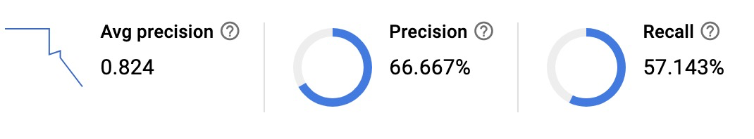

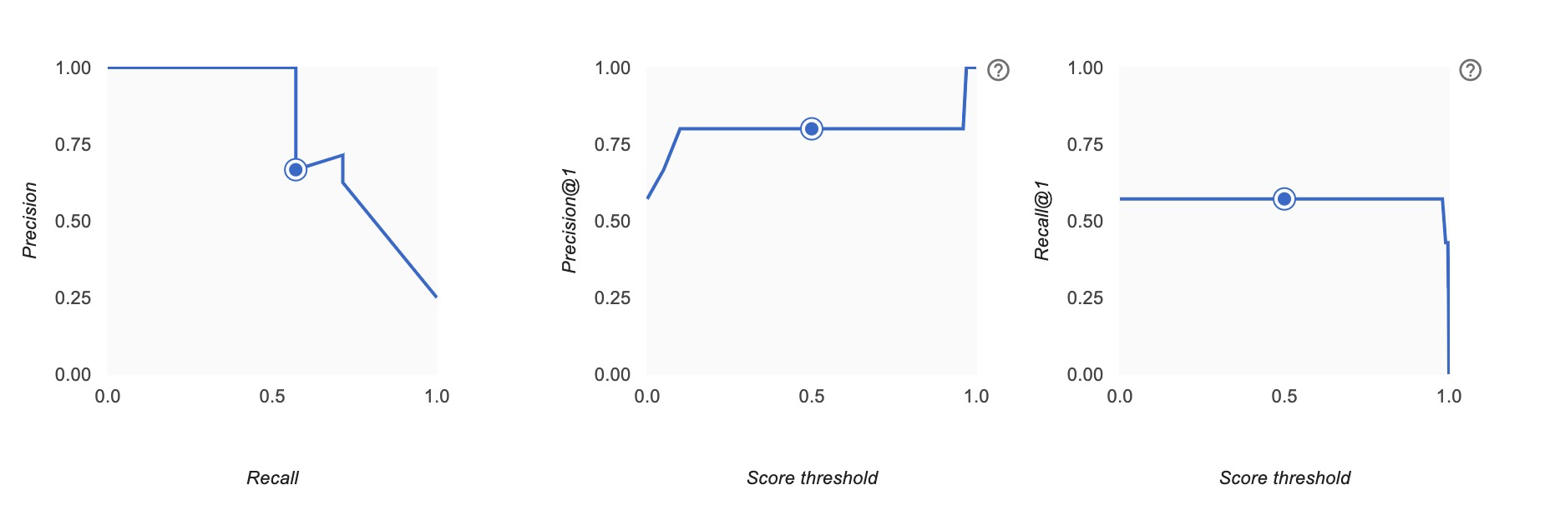

**Claims Classification:**

After classifying all of the tweets into their four respective buckets we then separated the tweets classified as “claims” and began classifying them as true or false claims labeled as 0 and 1 respectively.

To accomplish this manual classification, we utilized our Fact Repository to make determinations on the verifiability of the claims. Our initial bucketing filters us down to 452 tweets that were classified as claims which were distributed 325 verifiably True and 127 verifiably False.

This labeled dataset was then used as our training data set in creating a model for the true and false claims. The dataset was split even further by an 80/20 split for the training and validation data to be used in cross validation of our model.

The data was initially one feature, the text, and the label itself. Once the data was entered into python the text was cleaned, we removed numbers, punctuation, and stop words, and all letters were made to be lowercase.

Accuracy: 77% Precision: 81%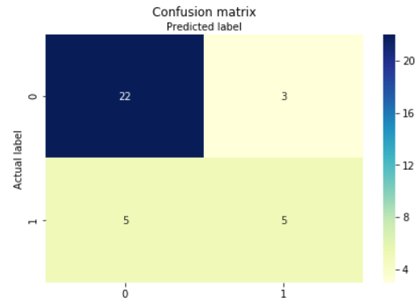

Recall: 88% F1 Score: 85%

### 

### **Data Cleaning**

The following steps were used for the cleaning of data:

Original tweet- *@JohnHard3 @VirginiaInCal @truthglow @GrainOfSands Glyphosate Found in Childhood Vaccines .... The detection of glyphosate in vaccines ... would indicate the presence of other co-formulants which are also toxic .... Moms Across America sent a letter ... requesting that ....*

1. Changed to lowercase- *@johnhard3 @virginiaincal @truthglow @grainofsands glyphosate found in childhood vaccines .... the detection of glyphosate in vaccines ... would indicate the presence of other co-formulants which are also toxic .... moms across america sent a letter ... requesting that ....*
2. Removed usernames- *glyphosate found in childhood vaccines .... the detection of glyphosate in vaccines ... would indicate the presence of other co-formulants which are also toxic .... moms across america sent a letter ... requesting that ....*
3. Removed all special characters and numbers- *glyphosate found in childhood vaccines the detection of glyphosate in vaccines would indicate the presence of other coformulants which are also toxic moms across america sent a letter requesting that*
4. Removed all stopwords- *glyphosate found childhood vaccines detection glyphosate vaccines indicate presence coformulants also toxic moms across america sent letter requesting*

### **Analysis**

* All the buckets have approximately uniform distribution. Claims being the 22.6% (Fig.1)
* Among the claims classified 72% (326 Tweets) were not fake and 28%(126 Tweets) were fake (Figure.1)

### *Figure.1 Distribution of Tweets*

* Figure.2 shows the number of total Tweets made by each user and the number of fake tweets among them ranked and color saturation in the decreasing order of the fake tweets made

### 

*Fig.2 Fake vs Total Tweets by each user*

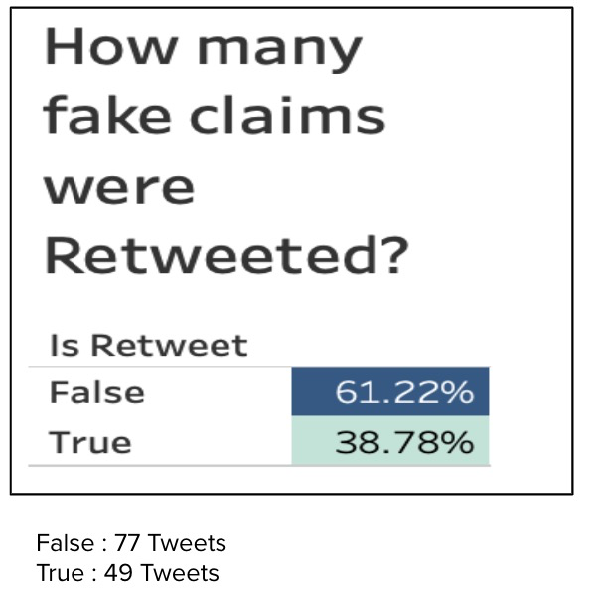

Fig 3 illustrates the number of fake claims that were retweeted. 49 Tweets were retweeted, which it indicates the spread of false news to other users too.

*Fig.3 Retweet count*

Fig 4 visualizes number followers and friends of the top 10 users who have made fake claims the most. This figure also illustrates the scale of influence their fake claims can make to their followers and friends.

### 

*Fig.4 Social Influence*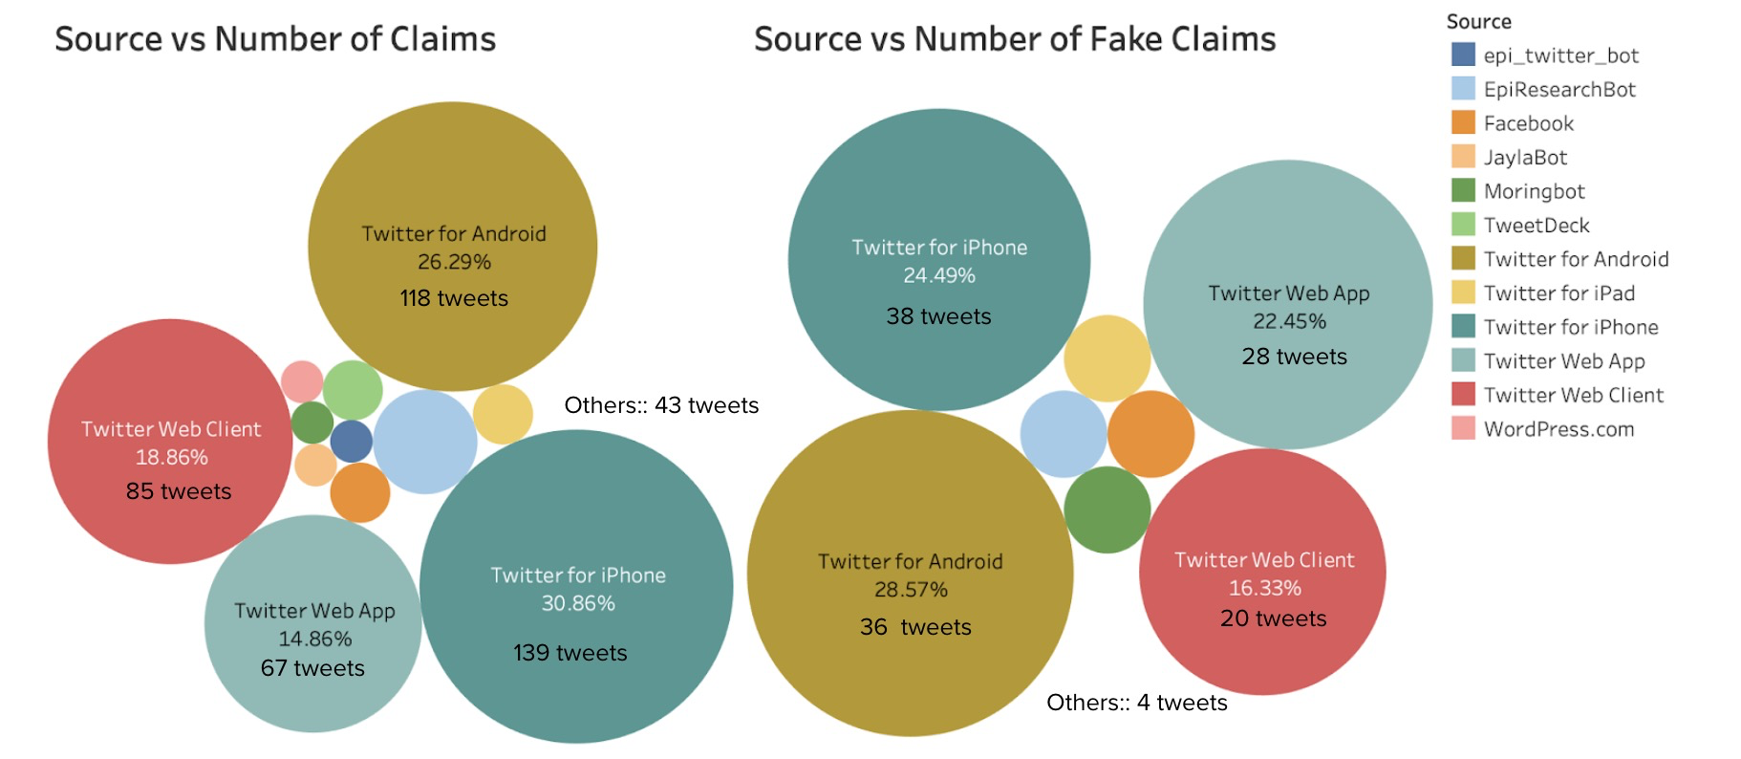

Figure 5 visualizes the different sources of the tweets that were classified as claims and the tweets that were fake. Most number of claims were from Android users but the fake claims were most among the iPhone users.

*Fig.5 Source of claims and fake claims*

### **Result**

**Fake Claims**

**Example 1**: not only are many vaccines filled with toxins but gardasil is dangerous unnecessary amp ineffective it has not decreased cervical cancer but sure has harmed tens of thousands of the people you are supposed to protect

**Example 2**: a large new study finds kids who got no childhood vaccines were more likely to be diagnosed with autism than kids who did get recommended vaccinations

**Non-Fake Claims**

**Example 1:** the hpv vaccine is most effective during adolescence when the body produces more antibodies against the virus thats why recommends the vaccine at ages 11 or 12

**Example 2**: modern vaccines are highly effective and safe they do not cause autism or contain toxic chemicals

**References**

1. <https://nrvs.info/faqs/can-vaccines-cause-or-spread-diseases/>
2. <https://www.rush.edu/health-wellness/discover-health/7-myths-about-vaccines>
3. <http://protomag.com/articles/rise-fake-medical-news>
4. <https://science.sciencemag.org/content/359/6380/1146.full>
5. <https://www.webmd.com/a-to-z-guides/health-quackery-spotting-health-scams#2>
6. <https://health.usnews.com/health-care/for-better/articles/2017-05-23/medical-news-real-or-fake>
7. <https://www.philly.com/philly/health/5-useful-sites-to-fact-check-fake-health-news-20180717.html>
8. <https://www.factcheck.org/>
9. <https://www.publichealth.org/public-awareness/understanding-vaccines/vaccine-myths-debunked/>
10. <https://www.cdc.gov/vaccines/vpd/vaccines-list.html>
11. <http://www.bphc.org/whatwedo/infectious-diseases/Infectious-Diseases-A-to-Z/Pages/Vaccination-Myths-and-Facts.aspx>

### 

### 

### 

### 

### 

### 

### 

### **Appendix**

You can now run predictions on text items using your custom content classification model.

**Code Classification 1:**

**import sys**

**from google.cloud import automl_v1beta1**

**from google.cloud.automl_v1beta1.proto import service_pb2**

**def get_prediction(content, project_id, model_id):**

**prediction_client = automl_v1beta1.PredictionServiceClient()**

**name = 'projects/{}/locations/us-central1/models/{}'.format(project_id, model_id)**

**payload = {'text_snippet': {'content': content, 'mime_type': 'text/plain' }}**

**params = {}**

**request = prediction_client.predict(name, payload, params)**

**return request # waits till request is returned**

**if __name__ == '__main__':**

**content = sys.argv[1]**

**project_id = sys.argv[2]**

**model_id = sys.argv[3]**

**print get_prediction(content, project_id, model_id)**

**get_prediction("YOUR TEXT HERE" fakenews594-1555966101137 TCN6216428474581964178)**